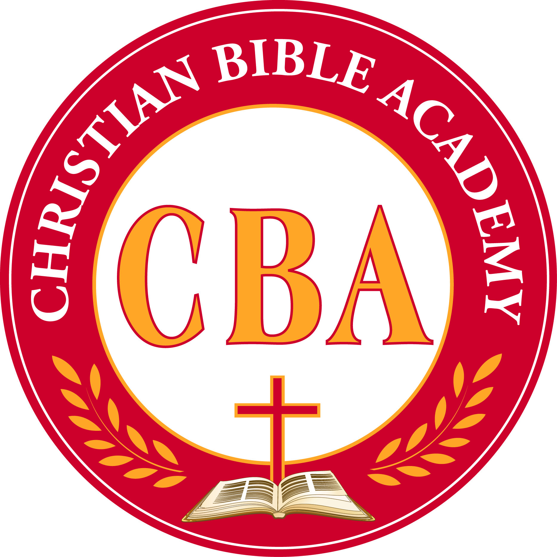

Christian Bible Academy
Operational Policies/
Parent Handbook

3222 Texas Parkway
Missouri City, TX 77489
281-835-8027 or 281-924-9902 phone
281-835-8927 fax

CBA Mission
To assist in raising young children in the knowledge of Christ, that they may fulfill the great commission to make disciples of all men. To assist in the total development of a child contributing to physical, social, emotional, spiritual and intellectual growth of all children in our care. Galatians 4:19 – I labor until Christ be formed in you. And Jesus increased in wisdom and stature and in favor with God and man. Luke 2:52

Statement of Commitment
Welcome to the Christian Bible Academy Family. You are about to join an outstanding team of dedicated professionals. We are pleased you chose Christian Bible Academy to be a part of your child’s education career.

Christian Bible Academy has previously been in existence for 10 years and we are elated to be open again to serve you and the community. Our rich history includes stellar accomplishments of hundreds of children. We believe that every child is capable of learning and it is our job as educators to simply illuminate and guide that which God has already given them. Our mission is to be a visible source of education for all children and to provide an environment that meets the spiritual, social and emotional, cognitive and physical needs of every child.

Website
To find out more information about the church or school go to www.Powerhouseoflove.org. (Website currently being updated to include the school) Parents are encouraged to check the website for updates and school forms and information or stop by the Directors office where Operational Policy and all other pertinent information pertaining to licensing is locate in a binder on the Director’s desk.

School Hours
Christian Bible Academy is open from 6:00 a.m. to 6:30 p.m. Monday through Friday- Year round; January through December. The instructional day begins at 8:00 a.m. and ends at 4:00 p.m. – tuition covers from 6 a.m. to 6:30 p.m. Children in attendance before 8:00 a.m. and after 4:00 p.m. who child do not attend CBA all day are considered Before and After School Children and participate in our After School program –these parent pay a different fee for Before and After School Care.

TABLE OF CONTENTS
CBA MISSION…………………………………………………………………………………………………………………………………………..Page2

STATEMENT OF COMMITMENT………………………………………………………………………………………………………….Page2

WEBSITE…………………………………………………………………….…………………………………………………………………………….Page2

SCHOOL HOURS……………………………………………………………………………………………………………………………………..Page2
TABLE OF CONTENTS...................……………………………………………………………………………………………………..Page3/4

HOLIDAYS………………………………………………………………………………………………………………………………………………..Page5

ADMISSION POLICY…………………………………………………………………………………………………………………………...Page6

DISMISSALS……………………………………………………….…………………………………………………………………………………….Page6

HOURS OF OPERATION...…………………………………………………………………………………………………………………..Page6

CBA FEES………..………………………………………………………………………………………………………………………………………Page7

MORE ABOUT GENERAL FEES………….……………………………………………………………………………………………….Page8

BEFORE AND AFTER SCHOOL FEES………….……………………………………………………………………………………….Page8

PAYMENT POLICIES/FACTS TUITION PROGRAM………….………………………………………..…………………..Page8/9

INCLEMENT WEATHER……………………..……………………………………………………………………………………………..Page9

PARENTAL NOTIFICATION……..……………………………………………………………………………………………………..Page9/10

LUNCH/LUNCH PAYMENT…………………………………………..………………………………………………………………..…Page10

FORGOTTEN LUNCHES……………………………………………………………………………………………………………………..Page10

APPLICATION/REGISTRATION AND MATERIAL FEES …..….………………………………………………………..Page10

WITHDRAWAL POLICY ………..…………………………………………………………….……………………………………………Page11

ABSENCES…………………………………………………….……………………………………………………………………………………..Page11

LATE PICK-UPS ………………………….…………………………………………………………………………………………………………Page11

SNACKS/ LUNCH………………….……………………………………………………………………………………………………….………...Page11

FOOD ALLERGIES…………………..……………………………………………………………………………………………………………..Page11

CLASSROOM VISITS………………………………………….………………………………………………………………………………….Page12

PERSONAL ITEMS………………………………………………………………………………….………………………………………..…..Page12

CLASSROOM CELEBRATIONS/ACTIVITIES…………………………………….………………………………………….......Page12

BIRTHDAY CELEBRATIONS ……………….……………………………………………………………………………………………...Page12

ILLNESS ……………………………………..……………………………………………………………………………………………………..……Page13
VACCINATIONS ……………………………………….………………………………………………………...………………..……………..Page13

IMMUNIZATIONS ………………………………………………………………………………….……………………………………….Page13/14

VISION/HEARING SCREENING…………………………………………………………………………………………………………..Page14

MEDICATIONS……………………………………………………………………………………..………………………………………….Page14/15

EMERGENCIES/INCIDENTS...................................................................................................................Page15

EMERGENCY PREPAREDNESS PROCEDURES/PLAN..………….………………………………………….........Page15

TABLE OF CONTENTS (CONTINUED)

EVACUATION, RELOCATION AND SHELTERING/LOCK DOWN OF CHILDREN.…………..Page15/16/17
ACCIDENT REPORTS ……………………………………………..…………………………………………………………….………………Page17

REPORTING ABUSE/NEGLECT……………………………………………………………….………………………………….….Page17/18

HEALTH CHECKS ………………………………………………………………………………….……………………………………………….Page18
.
BEHAVIOR MODIFICATIONS/DISCIPLINE…..………………………………………………………………………………Page18/19

BITING.................................................................................................................................................…..Page19

PARENT CONFERENCES…………………………………………………………………………………………………………..……..…..Page19

CLASSROOM COMMUNICATION/DAILY REPORTS …………………….………………………………………………..Page19

HOMEWORK…..……………………………………………………………………………………………………..……….…………………….Page20

FIELDTRIPS……………………………………………….…………………………………………………………………………….……………..Page20
TRANSPORTATION………………………………….…………………………………………………………………………….…………….Page20

WATER ACTIVITIES ……………………………………………………………………….…………..…......................................Page20

CONFIDENTIALITY ……………………………………………………………………………………………………………………………….Page21

MEETING WITH ADMINISTRATION……………………………………….……………………………………….……..…………Page21

PARENT COMMUNICATION.……………………………………………………………………………………….…………............Page21

GRIEVANCE PROCEDURE…………………………………………………….………..……………………………………………………Page21

UNIFORMS……………………………………………………………..….…………….………….……………………………………………..…Page21

SIGN-IN AND /OUT RELEASE OF CHILDREN..…………………….…….……………………………………………….Page21/22

PARKING/DRIVING ON CAMPUS………………………………………………………………………………………………….….Page22

PARENT PARTICIPATION…………………………………………………………………………………………….….…….………Page22/23

VOLUNTEER POLICY…………………………………………………………………..…….………………..….…………………………….Page23

BREAST FEEDING ……………………………………………………………………….…………….…………………………………………Page23

COMMITMENT AND CHRISTIAN SERVICE……………………………………………………………………….................Page23

STATE OF TDFPS/MIMIMUM STANDARDS.………………………………………………….……………….................Page24

SUBCHAPTER L, DISCIPLINE AND GUIDANCE..………………………………………………….………………………Page24-25
GANG FREE ZONE………………………………………………………………………………..……….……….….…………………………Page26

OPERATIONAL POLICIES……………………………………………………………………..…………..………….……………………..Page27

Holidays
Christian Bible Academy observes the following National Holidays:

New Year’s Day January 1st

Dr. Martin Luther Kings’ Birthday Corresponding Monday in January

Good Friday The Friday preceding Easter Sunday Closed at
Noon (12:00)

Memorial Day The last Monday in May

4th of July July 4th

Labor Day The first Monday in September

Thanksgiving Day Wednesday closed at 2:00p.m., the fourth Thursday and Friday after.

Christmas Eve December 24th

Christmas Day December 25th

New Year’s Eve December 31th

New Year’s Day January 1st
See your school year calendar.

The Aftercare Program follows schedules from the Fort Bend ISD School and Stafford MSD closings for Christmas, Spring Break and Thanksgiving. Please note that there is no reduction in fees for these closings. The Child Development Center does not close for Spring Break. There is an extra minimum charge during these holidays for the school age children for being in care longer. Cost will include tuition and activities for those who will attend.

In addition, Christian Bible Academy closes the school two days prior to the opening of the school year in August for building maintenance and teacher preparation.

Admission Policy

Christian Bible Academy is open to any student without regards to race, religion, sex or disability. Each student must meet the guidelines and financial obligation set by the school.

Enrollment Policy

All forms must be filed completely and submitted before child can be admitted /attend school.

Suspension/Dismissals

At Christian Bible Academy it is our mission to meet the spiritual, social and emotional, cognitive and physical needs of every child. However, Christian Bible Academy reserves the right to ask parents to suspend and/or make alternative arrangements for care, if it is determined that a child’s needs cannot be met or the child is not adjusting to the care as provided by Christian Bible Academy. Please know that suspensions or dismissals are carefully considered and if the school determines that our program is not the right fit.

Suspension/Dismissals can also be considered for the following:

- Being uncooperative with teachers and staff.
- Being a risk to other children or to self
- Abusive / threatening to teachers, staff, or students.
- Failure to complete enrollment process or to turn in necessary forms/paperwork.
- Failure to pay your tuition in a timely manner.
- Failure to comply with state or county regulations.
- Failure to comply with Policies and Procedures as outlined in the Parent Handbook.

Center Hours – 6:00 a.m. to 6:30 p.m. /
Before and After School service is also available to serve you.

More about General Fees………..

It is our policy to provide the highest possible educational experience at the lowest possible cost without sacrificing one for another.

Activity and other fees (such as fieldtrips, school pictures, etc.) may be charged during the school year and the terms for payment will be given when the fee is charged.

Tuition is based on an equal 9 (nine) month school year and the monthly tuition rate remains the same throughout the year. Summer Camp tuition can be paid separate or will continue as the child continues. No exceptions are made for school holidays or national holidays, school in-service days or personal vacation time, illness and natural disasters or weather related closures. This secures your child’s space at Christian Bible Academy.
Every family must be enrolled in the FACTS Tuition Management Program for collection of monthly payments, for payment options please see the section under FACTS Tuition Management Program.
Please note that in order to reconcile our books for each semester, there are two months during the school year that tuition is due on the 5th of the month, December and May, no exceptions.
Before and After Fees (Aftercare)

Before and After Care School fees are to be paid on a monthly basis due on or before the 5th and 20th of the month. Each parent must sign a service agreement with FACTS Tuition Management Company, the company outsourced to collect all tuition payments. Tuition is based on an equal ten month school year and the monthly tuition rate remains the same throughout the year. No exceptions are made for school holidays or national holidays, school in-service days or personal vacation time, illness and natural disasters / weather related closures. This secures your child’s space in the Christian Bible Academy Aftercare Program.
Payment Policies (options) FACTS Tuition Program

Tuition is due in full and paid on either the 5th and 20th of the month. Each parent must sign a service agreement with FACTS Tuition Management Company, the company outsourced to collect all tuition payments for the Christian Bible Academy School. https://online.factsmgt.com/singin/4K9DP

- Payment in full. (entire 9 (nine) months) This payment, due August 25th, may be made directly to the school by check or cash and will entitle you to a $100 discount on annual tuition.
- Payment through FACTS. There is a $45 annual fee per family for paying through FACTS.
- Automatic Bank Payments through your checking or savings account can be made on either the 5th and 20th of the month.
- 9 months September – May (5th and 20th) Except May and December on 5th.
- Per Semester (2 payments, 1 per semester due in September and January)
- Quarterly (2 payments per semester in Sept and November and January and March)
- MasterCard, AMEX, or Discover. Automatically scheduled monthly payments through your credit card; please contact the business office and the appropriate form will be sent to you. Each payment will incur a 2.5% credit card convenience fee*.

All checks returned for insufficient funds will be charged a $30 returned check fee from FACTS Tuition Management Company and $30.00 fee from the Christian Bible Academy. Consecutive notices of insufficient funds will result in the termination of your contract and the release of your child from the Christian Bible Academy. These payment options also apply to all Before and Aftercare students. These are the only payment options available to parents.

Any account that has a past due balance will not be allowed to register for the next school year until the account is settled.

Tax information will not be processed during tax season if there is a balance due at the school.

Any student with tuition payments more than 30 days delinquent will be subject to subsequent removal from school.

Please contact the Christian Bible Academy Business Office if an extenuating circumstance arises with regard to tuition payments.

All receipts will be available if requested 24 hours after the payment has been posted.

Inclement Weather
The school takes into consideration several factors when making judgments on weather related closures. Assessments are made based on recommendations from our local authorities, road conditions and forecasted alerts. Please contact the school, check the website regularly, watch television or listen to radio alerts for announcements regarding Fort Bend School closures. When Fort Bend Schools are closed please note CBA will also be closed. This is important to note in cases where we are not able to get through to parents.

Parental Notification
In case of inclement weather or any other situation CBA will notify parents via Mass emails, telephone and/or text messages.
This form of communication will be sent out on behalf of the school in order to keep everyone informed at all times of various circumstances regarding the school.
Please note that no deductions in tuition fees are made in the event the school must close for weather related closures. This secures your child’s space at Christian Bible Academy.

Lunch / Lunch Payments

The Christian Bible Academy School utilizes the services of a private caterer to provide meals for students. The food is not prepared at our school, rather at the establishment of our private caterer. Our caterer is, Cue Burgers and More, they are a licensed restaurant in the Stafford area and have catered for the Christian Bible Academy in previous years. Parents have the option of purchasing lunches through our private caterer. A menu will be provided at the beginning of every month and lunch payments are made directly to our caterer and are paid no later than the 5th of every month. No late payments will be accepted for lunch orders. In order for you to receive a credit for your child’s lunch when they are absent, you must contact the school office no later than 9:00 a.m. and inform us that he/she will not be in attendance and will not require a lunch for the day. Menus are available on our website or in the school office.

Lunch is not included in the price of tuition. Your child has the option of bringing his/ her lunch on any day you choose. If you do send a lunch, please make sure that the food does not require heating. Also, when preparing the lunch please consider the time your child will be at school and the nutritional value of the meal.

Please write the full name of your child on every payment. All checks returned for insufficient funds will be charged a $30 returned check fee and checks will no longer be accepted from you on your child’s lunch account. We will require payment in cash or money order only.

Forgotten Lunches
If a student forgets his/her lunch, a lunch will be ordered through the private caterer, or nearby business, the parent will receive a bill for the lunch that was provided. The parent can bring sack lunches for their children as well and leave it in the school office until lunch time.

Application / Registration and Material Fees
The application and material fee is a non-refundable fee. It is an annual fee that is submitted along with the pre-application for enrollment. The annual supply fee is due and payable by August 1st or upon registration and is also non-refundable.

Withdrawal Policy
Intent to withdraw a child from the school must be submitted in writing 30 days in advance. No documents or progress reports/grades/report cards will be given until tuition is paid in full and the account is properly closed out. There is no tuition refund. Cancellation of your FACTS Service agreement can be done directly through the school office.

Absences
The Christian Bible Academy School bases its operating cost on annual projections. In order to continually assure the highest quality of staff personnel, equipment, and supplies, no exceptions are made for absences due to school holidays / national holidays, school in-service days or personal vacation time, illness and natural disasters or weather related closures. This secures your child’s space in the Christian Bible Academy.

Late Pick-ups
The school closes at 6:30 p.m. Late charges begin accruing at 6:35 p.m. A late fee of $5.00 is automatically charged at 6:35 and a $2.00 per minute thereafter. You will be asked to sign a “Late Pickup” form. Please note that in the event you are late, it is your responsibility to pay any late charges directly to your caregiver on the date of your late arrival / pick up.

Snacks
The Christian Bible Academy School provides a morning and afternoon snack. Your child will be offered a nutritious snack. Parents are welcomed to send breakfast and/or a snack if the child has a specific preference. We also ask that parents please pack a daily water bottle. If a parent provides a meal or snack from home CBA is not responsible for its nutritional value or for meeting the child’s daily food needs.

One last note: when preparing lunch and / or snack, we ask that you exclude all foods and beverages containing high levels of sugar such as sugar coated cereals, doughnuts, cake, cookies, candies and red punch. If you child arrives with such items, they will be offered an alternative snack. If you arrive after 8 a.m. please finish breakfast before entering the classroom, you may use the coffee shop area.

Food Allergies
Please notify the school of any food allergies by indicating on your enrollment file, the teacher and school office. Your child’s name will be added to our allergy list that is posted in every classroom. With new rules from licensing each child with food allergies, parent/guardian needs to bring to school food allergy plan. Please fill out the proper plan forms and they must be signed by both parent/guardian and the child’s doctor for usage in the school office so that we can administer in the event it is necessary. Parents must have plan of action regarding the allergy detailing what must be done.

Classroom Visits/Procedures for parents to participate
Parents are always welcomed visitors. Visitations should be arranged with the office and in advance of the time of the visit if possible, however, it is not mandatory that classroom visits be scheduled. Parents may walk in at any time to observe their child the schools operation and program activities. Christian Bible Academy has an open door policy. Visitors must check in at the front office. Parent visits may last no longer than 30 minutes (unless the parent is volunteering or it is a special celebration) since children work better with fewer distractions and less interruptions. In order to ensure a meaningful visit, siblings or friends (children) are not allowed in the classroom. If a conference is requested with the Director to address any questions or concerns about the policies and procedures please call the school offices, rather than using the visitation as a conference time.

Personal Items
Personal items such as, blankets, toys, electrical equipment or other personal items are not allowed and CBA is not responsible for any lost items. Other items for infant use must be labeled. For example: cups, bottles, pacifiers, lunch kits, back packs etc.

Classroom Celebrations / Activities
There are several occasions during the school year when class celebrations / activities are planned. Class parties are kept as simple as possible with emphasis on the meaning of the event. Room moms will coordinate parties with help from parents and teachers. Please be mindful that we have children with food allergies and only store bought goods are allowed, no nut or peanut products are allowed.

Birthday Celebrations
In School – Students will receive a birthday blessing during the chapel service closest to his / her birthday. Parents may send simple birthday treats for snack time or lunch to honor the birthday child. The Department of Health requires that the treats be store-bought. Please make arrangements with the teacher as some of our children have food allergies. Gift giving and other party type activities are not appropriate for school.

Private party invitations to private parties may be given out at school only if all children in the class are included. The school encourages parents to be aware that sponsoring a birthday party that excludes children in the class is hurtful to the excluded children and detrimental to the development of community spirit. The school relies on parents to guide their children when making a party list.

Illness
No rules are more important or taken more seriously than those having to do with a student’s health and well-being. If your child becomes ill at school the parent or guardian will be contacted for pick up. If the parent or guardian is unavailable an emergency contact will be contacted. Children that run a fever of 100F and above will be sent home and asked to remain at home until there is no sign of fever for a period of at least 24 hours. If a child is vomiting or has diarrhea the child will also be sent home and asked not to return until there are no signs of vomiting or diarrhea for at least a period of 24 hours. Precautions are taken on a daily basis to minimize the spread of any virus that might affect other children. If your child requires emergency care we will call 911 emergency services.

Vaccinations
There is no statewide requirement for teachers or other school employees to have any vaccinations including tuberculin skin test. The Center for Disease Control and Prevention discourages the use of any vaccinations including tuberculin skin test for persons who have no risk factors or exposure to any diseases including TB therefore; Christian Bible Academy does not require any vaccinations including Tuberculin Skin Testing for the staff. Christian Bible Academy does not require the TB skin test for children.

IMMUNIZATIONS
The school requires that an immunization record be on file before entering the school year. Returning students will only be required to submit an updated immunization form for any NEW vaccines given. These forms must be on file the first day of school.

According to the American Academy of Pediatrics (AAP), children require frequent boosters and immunizations in early childhood. Since the risk of vaccine preventable disease is increased in group settings, ensuring appropriate immunization is an essential responsibility in child care. Based on these guidelines, The Christian Bible Academy School has the following guidelines:

- The Christian Bible Academy School requires that all students who turn four must have a DTaP and a Polio vaccine within 30 days after their fourth birthday. Also the student must have at least 2 doses of the MMR vaccine after the first birthday and within 30 days after the fourth birthday.
- Students must also be vaccinated against Hepatitis A (two doses), Hepatitis B (three doses), Varicella (two doses) and Pneumoccal disease. If questions arise, please contact the school office for clarification.
- At the age of eleven, students need a Td booster. At this time, the AAP is also recommending a booster for Pertussis. It is combined in with Tetanus and Diphtheria and called Tdap. Meningococcal vaccine is also recommended.

Parents who do not want their children to receive these vaccines due to a reason of conscience may go to the Texas Department of Health Website at www.dshs.state.tx.us and fill out a request in Austin. They will then send a form to you that must be signed and notarized. The school office MUST receive a copy of this form for your child’s permanent record before they may begin school or before the immunization due date.

VISION AND HEARING SCREENING
Each year students in Preschool 4 yr. olds, Pre-K and Kindergarten ALL new students are required by state law to have vision and hearing, height and weight screening. Screening may be done by your doctor or at school when offered. (It is the responsibility of the parent to get the screening done) Parents will receive prior notice of school screenings and will be notified of any apparent deficiencies.
MEDICATIONS
Procedure for taking medicine during school hours – Any student who must take medicine during school hours MUST comply with the following procedures:

- All medicine must be furnished by the parent.
- All medicine must be locked in the office cabinet.
- All medicine, prescription and non-prescriptions, that are to be administered at school, MUST be accompanied by a written request signed and dated by the parent or legal guardian or signed in to the Medication Log located in the school office.
- All medicine must be signed in daily

All prescription medication MUST be in the original pharmacy container and labeled by the pharmacist. The label MUST include:

- Students name
- Physician’s name
- Name of the medication
- Amount of medication to be given and the frequency of administration
- Date the prescription was filled.

All non-prescription medications MUST be in the original container. The written request must contain the following information:

- Name of student
- Name of medication
- Amount of the medication to be given
- When the medication is to be given
- Reason the medication is to be given
- Date
- Signature of the parent or guardian
- A Doctor’s note is needed if the medication has to continue being given at school more than 3 days.

There shall be no more than one (1) medication per properly labeled container. If injectable medication is provided for any acute reaction, such as is given for asthma, insect bites or stings, hemophilia, etc., a physician’s written authorization, as well as, the parent’s written request IS REQUIRED. Regular allergy injections WILL NOT be given at school. Students may not keep medication in their possession. Children may bring their own sunscreen or insect repellant. They should be labelled with the child’s name, parents will not need to give us permission to apply.

Emergencies/Incidents
Minor accidents occurring during school hours will receive prompt and careful attention from our teachers. All incidents are documented. We will notify you in the event of a serious illness or accidents. In the event of a medical emergency, the school will contact 911 for emergency medical care to be rendered or if this is not necessary first aid will be rendered at the school and an incident report will be issued and the parent will be contacted immediately.

Please note that it is your responsibility to have medical insurance or other financial arrangements for your child/children. Also, it is very important that you immediately inform us of any changes of address and telephone numbers at home and at work.
Safety Practices
Safe Sleep: CBA enrolls 12 months and up, no cribs. All staff is SIDS trained.
Emergency Preparedness Procedures/Plan
In the event of an emergency such as the following:
- Fire
- Severe weather
- Bombs / structural damage
- Power outages
- Intoxicated Parents
- Intruders
- Lost or Abducted Children
- Chemical Spills
- Transport Accidents / Vehicle Breakdown
Evacuation, Relocation and Sheltering/Lock down of Children:

- Evacuation, relocation, and sheltering/lock-down of children states that:

- The first responsibility of staff in an emergency evacuation or relocation is to count and make sure they have all of their children, and move the children to a designated safe area or alternate shelter known to all employees, caregivers, parents, and volunteers, The St. Joseph Syro Catholic Church, 211 Present Streets, Missouri City, Texas, 281-969-7236 is our out of school shelter. Children will be counted there too and documented.

- The children will be evacuated or relocated to the designated safe area in the gym or alternate shelter including specific procedures for evacuating and relocating children who are under 24 months of age and children who have limited mobility or who otherwise may need assistance in an emergency

(such as children who have mental, visual, or hearing impairments) will be carried out by school personnel by use of an evacuation crib, strollers or wheel chair. A wheel chair is located in staff room and will be used to evacuate them.

- The staff will be responsible for head counting children and matching with attendance sheet and document. Also for the orderly movement of children to a designated location within the center (school gym) or sheltering/lock-down place. The staff will recount the children and document every 20-30 minutes.

- An emergency evacuation and relocation diagram as outlined is posted in each classrooms and office.

- Name and address of the alternate shelter away from the center to be used as needed is The St. Joseph Syro Catholic Church, 211 Present Streets,
Missouri City, Texas, 281-969-7236.

- Children in attendance at the time of the emergency will be accounted for before and at the designated safe area or alternate shelter by use of attendance sheet.

2. Communication, including:

- The emergency telephone number that is on file with us; and Mrs. Valarie White 281-924-9902 and Mrs. Lucy Tenende 832-338-7222

- Will communicate with local authorities (such as fire, law enforcement, 911,
emergency medical services, health department)/ parents emergency numbers and License number 832 278 7054.

3. Staff will evacuate and relocate with the essential documentation including:

(A) Parent and emergency contact telephone numbers for each child in care;

- Authorization for emergency care for each child in care; and

- The child tracking system information for children in care;

4. The staff will continue to care for the children until each child has been released, using books, inside games, songs, and snacks.

5. We will reunite the Children with their parents as the evacuation, relocation, or sheltering/lock-down is lifted. Parents will be called by mass text to come pick-up their children after lockdown or shelter is lifted.

Evacuation routes and diagrams are posted throughout the facility. Each staff member has been trained to follow the procedures for the evacuation process. An evacuation will take place in the event of fire or gas leak or a relocation of children and care givers to an alternate shelter in an emergency such as flood, hurricane, medical emergency or communicable disease outbreak to be protected from situations such as tornados or a volatile or an endangering person on the campus.

The staff will carry their emergency bag which has the attendance sheet with the full names and birth date of all the children there on that day and parent emergency contact phone number for each child, (should it be necessary to contact them for pick-up) authorization for emergency care of each child, first aid kit, books, toys, puzzles and games (to keep them busy until parents pick them up will also be included) and snacks. Head count will be done to match the attendance roster. Every twenty (20) minutes and will be documented.

If an emergency should arise and evacuation is necessary, the first responsibility of staff is to count and move the students of Christian Bible Academy to the alternate shelter site, The St. Joseph Syro Catholic located at 211 Present St., Missouri City, TX 77489. 281-969-7236. Telephone calls, mass e-mails and text messages will be sent out to inform parents/guardians and how to reunite them with their kids. Parents may contact Ms. Valarie White at 281-924-9902 and Lucy Tenende 832-338-7222.

Fire Drills and Severe Weather Drills and lockdowns are conducted as mandated in State Minimum Standards and the school is equipped with a fire alarm system, sprinkler system and fire extinguishers where needed. Checks on these items are conducted.

Accident Reports
Staff members are required to report and document any minor injuries such as cuts, abrasions, bruises and /or insect bites. Minor first aid will be applied at the school if necessary. Parents will be contacted and given a written incident report indicating the nature of the injury/incident that will be filed in the child’s record. If emergency medical attention is required we will contact 911.

Reporting Abuse and Neglect
In the event that one of our trained personnel / staff is suspicious of the neglect or abuse of a child, it is the responsibility of the caregiver to report this suspicion directly to TDFPS or to school Administration. If administration feels that the neglect/abuse is accurate, social services will be contacted to begin a formal investigation. All activity will be documented. Allegations will be received by the state of Texas Department of Family and Protective Services where it will be determined if an investigation will be completed.

As caregivers, we take our responsibilities to keep children safe and out of danger seriously and we have a responsibility to protect children and report abuse / neglect when necessary. The following are methods that will take place
- Required yearly training – required every staff person for the prevention of and recognition of symptoms of abuse and neglect
- We will report any findings to the necessary authorities.
- Special attention will be given to warning signs: bruising, change in personality, child withdrawing.

- We will increase parent/staff awareness by detailing prevention techniques and awareness of abuse and neglect information in our newsletter and periodically on the website or you may call the following…

In the event you suspect child abuse, parents may contact Texas Abuse/neglect hotline to make a report to 1.800.252.5400.

Health Checks
A health check is defined as a visual or physical assessment of a child to identify potential concerns about a child’s health, including signs or symptoms of illness and injury, in response to changes in the child’s behavior since the last date of attendance. These daily health checks will be conducted by our staff members in order to ensure that students are in a healthy condition when entering into our care. Signs that we look for may include:
- Breathing difficulties
- Severe coughing
- Discharge from the nose or eyes
- Changes in skin color
- Bruising or swelling
- Cuts, sores or rashes
- Fever
- If a child is asleep upon drop off the staff is instructed to wake the child for proper health checks.
- All soiled items will be placed in a plastic bag and sent home for cleaning. No items containing blood or bodily fluids will be washed on campus to further prevent cross contamination.

Staff members will communicate with parents on a daily basis to find out how their sleep, eating and drinking, toileting habits and/ or mood or behavior is / has been prior to drop off. Effective communication with parents is key elements of a health check. Staff will be trained annually regarding child abuse awareness and neglect. If a staff member finds any of the following symptoms, the staff member will make a recorded statement; notify the director and parents of such findings. In the event a staff member is suspicious of the neglect or abuse of a child via confirmation of the warning signs, appropriate actions will be taken.

Behavior Modifications / Discipline
The management and behavior of children is a top priority at Christian Bible Academy Preparatory School. We have developed a written Code of Conduct for our children Pre K (3 years) through Kindergarten. It is important that you review the Code of Conduct we want to insure our children know and understand our expectations.

The principle job of behavior modification / discipline belongs to the School Director or Designee. Teachers are instructed to dismiss from class any child that becomes disruptive to the entire group. Behavior modification includes exclusion from field trips, special functions both on and off campus, redirecting and / or special assignments for elementary age children (i.e. writing notes of apology, etc.)
Any child consistently being disruptive 3 times or more and present a risk to themselves or other children can be dismissed immediately.
Any child who strikes a teacher will be permanently expelled.

This section does not, nor is it intended to, define all types and aspects of behavior. However, school administrators have the authority to establish policies and procedures and to interpret and enforce these as necessary. Additionally, each teacher, within his/her classroom, may establish certain rules compatible with those established by school administration.

Biting: As a part of normal early childhood development, occasional displays of aggression are expected such as hitting, yelling and biting. Repeated incidents of biting
will not be tolerated. Such incidents will result in the following:
- 1st offense – written and verbal warning. Both parents will be notified in writing. Parents will be given resources to aid in the understanding and management of the biting, scratching or inappropriate behavior.
- 2nd offense – Parent Conference. For the safety of other children the parent will be asked to pick the child for the remaining portion of the day and conference with the Director about this behavior and outline steps in preventing the behavior.
- 3rd offence – Student Dismissal

Parent Conferences
All teachers are required to hold no fewer than two formal parent conferences per school year. More may be scheduled as necessary. Please do not attempt to hold a parent conference during instruction time. Our teacher priority is to instruct and supervise children. This ensures the safety of all children.

Classroom Communication and Daily Reports
Please be sure to check your child’s cubby box, backpack or check with teacher for classroom communication such as parent newsletters, daily reports, homework, etc. Check the parent information board in the classroom for upcoming events and classroom info. The school information board is located in the lobby near the front desk. Also, be reminded that we post most items on the website weekly or send via emails. If you would like to be added to our mass communication listing please stop by the school office.

Homework
The responsibility for academic achievement and excellence rests between the child, parent and teacher. The Abeka curriculum will require children to have practice sheets for math, phonics, reading assignments and weekly spelling lists but each teacher determines particular homework days.

The amount of time and effort parents put into supporting their child’s / children’s education usually determines the success that will be achieved. This means providing a quiet place at home for homework, making yourself available for assistance and monitoring your child to insure they are completing homework correctly and consistently.

The Christian Bible Academy Aftercare Program is an Enrichment Program, please communicate with your children that they must be honest and forthcoming with homework assignments. At CBA we have a rotating schedule for specified time allotments for each activity. It is the responsibility of the parent, not CBA, to ensure that homework is completed. CBA will not separate a child to complete homework, we will initiate homework and completion is expected to take place at home. All children will rotate with various planned activities as not to ostracize a child from their peers.

Fieldtrips
Field trips are designed to promote and encourage excellence and to enrich learning while providing motivation in other academics subjects. Parents, staff and students are required to wear their Christian Bible Academy T-Shirt on all school sponsored field trips. Parent chaperones are needed to ensure we have safe and productive field trips. Field Trip permission and transportation will only be provided with written consent of the parent/guardian. All Field Trips will be posted 48 hours in advance of the Field Trip.
Head count will be done before leaving school and documented and during field trip several head counts will be done and documented. Upon return, head count will be done by staff and office person and documented.

Transportation
Before and after schoolers transportation will only follow the new revised van safety plan and procedure of 2017. (Please see attached) Transport from CBA to elementary school and back. Children will be loaded and unloaded at the curbside. Children will not cross the street without an adult. All children will be accounted for by head count and compared to the attendance rooster while entering van and while exiting the van. Children are counted again and documented by the receiving person at the school. Driver will check each row and verify that no children are left on the van before parking it.

Water Activities

Students may participate in water activities periodically throughout the year, parents will be notified prior to water activities and be asked for consent for participation. Parents are also to specify upon admission, in writing, their consent for water activities or that they do not wish for their child to participate in water activities.

CONFIDENTIALITY
All information in student files is considered confidential. Information obtained by The Christian Bible Academy School will be released to others only if a current release form signed by the parent/guardian is on file. Information obtained from other schools or individuals cannot be released by The Christian Bible Academy School.

MEETING WITH ADMINISTRATION
The Director or Office Administration regarding policies and/or procedures; every effort will be made to address your needs or concerns immediately. It is recommended that you schedule a meeting with the Administration Assistant in advance so a mutually beneficial time can be arranged. In case of emergencies the director Mrs. Valarie White can be reached at (281) 924-9902/Mrs. Lucy Tenende (832)338-7222.

Parent Communication
Information is sent home every Tuesday concerning such things as activities, policies / procedures, updates, upcoming events, and projects. Monthly newsletters, menus, and school calendars or upcoming events will be posted on our website or sent via email as well. Please take the time to review our website weekly for important information. Notices may require your attention and sometimes, your response. We will communicate to you policy changes through policy addendum and email the changes. Please take the time to read all materials from school and to respond when requested. We, in turn, will be careful to listen and respond appropriately and timely to your questions, comments and or concerns. In the case of emergency please contact the Director, Mrs. Valarie White; she can be reached at (281) 924-9902/Mrs. Lucy Tenende (832)338-7222.

GRIEVANCE PROCEDURE
If you have a concern about your child’s progress or activities, that concern should first be discussed with your child’s teacher. After this conference, if concern remain, it is appropriate to seek an appointment with the Director or Staff Administration.

The Christian Bible Academy is licensed by the State of Texas Department of Family and Protective Services, for information about day care licensing offices and local representatives, please visit the DFPS website at www.dfps.state.tx.us or
9702 Bissonnet Street, #2200 West, Houston, Texas 77036. Parents can view a copy of the child care center’s most recent inspection report on our information board.

Uniforms

The CHRISTIAN BIBLE ACADEMY School is a Uniform school. All students
(Preschool 2 and above) must be in complete uniform the first day they attend school.

Uniforms are purchased through French Toast online at www.frenchtoast.com. The Christian Bible Academy source code is QS5WRGD. Our school will receive a 5% fundraiser rebate with every purchase.

Uniforms:

Boys: Navy Blue pants/shorts, blue oxford shirts, tie and vest.
Girls: Blue/Red Plaid Dress, blue peter pan button shirt, tie.

Shoes: blue or black rubber soled dress shoes. (Velcro closures if student cannot independently tie shoes)

Friday Attire:
CHRISTIAN BIBLE ACADEMY T-shirts / Polo Shirts and jeans!
Sign In and Out / Release of Children

An adult must sign all children entering and exiting our building in and out each day. Children should not enter the building alone. Please help us comply with our licensing standards by signing your child/ children in and out. If for some reason you have authorized someone else to pick your child up, don’t forget to remind them that they need to follow this procedure. They will also need to show a picture identification that will be placed in your child’s file. It is important to remember that only individuals listed on the child’s record for authorized pick up will be allowed to pick your child up. Changes or additions to pick up can be made in the school office. When a parent is in the building, and has already sign out the child/children, it is their responsibility for the supervision of the child/children.

We ask parents to please refrain from using their cell phones during pick up of students. Important information may need to be communicated with you at time of pick up. Furthermore, we ask that you keep a close hold on your child as you depart the building; others are coming in and out of the building as well as moving vehicles in the carport area.

Parking / Driving on Campus

When dropping children off or picking them up, please remember that we have a one-way entrance and exit for the school. In order to ensure the safety of all our children, we ask that you enter and exit properly. Also, handicapped parking is reserved for those persons needing unobstructed access to our school. Please do not use the handicapped parking for any reason unless you have the requisite authorization from the State of Texas.

- Please do not drive over 5 mph while in the parking lot.
- Please do not use your cell phone while driving on campus. Please do not Text and drive.
- Pedestrians always have the right of way.
- Please do not leave your vehicles running while you are picking up your children. Ignitions must be turned off and keys removed.
- Children may not be left unattended in a vehicle at any time or for any reason.

Parent Participation

We encourage parent participation at Christian Bible Academy. We believe that children develop and learn more productively when their parents are actively involved in their school life. We have a growing Parent Action Council (PAC). The sole purpose of the Parent Action Council is to raise funds for the school and increase volunteerism. PAC has no jurisdiction over administration, policies and / or procedures of the Christian Bible Academy School.

An exciting addition is the once a semester “Family Night”, where parents and children are invited for an evening of fun (children) and adult engagement (an interesting workshop or speaker).

In addition to “Family Night”, we are asking each parent to willingly give five hours per school year in volunteer time. A list of volunteer options is made available at monthly Parent meetings.

Volunteer Policy
Volunteering is an integral part of the school program and a great way to get involved. There are many areas in school where we need and want parent assistance. We have volunteer opportunities for everyone, whether volunteering a few hours or on a regular basis. We encourage parents to get involved by contacting the Parent Action Committee (PAC) or the school office for more information.

Guidelines:
- Volunteers must complete a background check form with a copy of a valid driver’s license.
- Volunteers check in at the front office.
- Volunteers must dress appropriately.
- Volunteers must keep all school information confidential.
- Volunteers may not bring young children.

Breast Feeding
Human milk is the best source of milk for infants and supports optimal health and development. CBA will provide any mother wishing to breast feed their child a private area with a place to sit to breast feed. Parents have the right to breastfeed or provide breast milk for their children while they are in care at CBA.

Commitment and Christian Service

Character in students is influenced by their role models. As parents, your commitment to Christian Service will have the greatest impact. Your children, in most cases, will value what you value and make sacrifices in accordance with what they see you are willing to sacrifice for.

Likewise, everyone at The Christian Bible Academy also serves as role models for your children. Through daily prayer, weekly Chapel Service, singing praise and worship songs, treating each other with respect and kindness, we model and demonstrate the development of Christian Character. Please know that our aim is to compliment what you are already doing. Thank you for choosing Christian Bible Academy Child Development and Preparatory School.

State of Texas Department of Family and Protective Services State Minimum Standards
The Christian Bible Academy is licensed by the State of Texas Department of Family and Protective Services. A copy of the following is available for view in the school office:
- Minimum standards may be reviewed upon request in the school office;
- Latest inspection reports (state, fire, health), are available in the school office, as well as,
- Operation License and Director’s License

For information about day care licensing and/or to contact to local representatives or gain knowledge of child abuse hot lines, DFPS website etc., please visit the DFPS website at www.dfps.state.tx.us or 9702 Bissonnet Suit 2200 W, Houston, TX 77036 713.340.3091.
Minimum Standards for Child-Care Homes
Texas Department of Family and Protective Services
Subchapter L, Discipline and Guidance
§747.2703. What methods of discipline and guidance may I use?
Subchapter L, Discipline and Guidance
April 2017
Discipline must be:
Medium (1) Individualized and consistent for each child;
Medium-High (2) Appropriate to the child's level of understanding;
Medium (3) Directed toward teaching the child acceptable behavior and self-control; and
Medium-High (4) A positive method of discipline and guidance that encourages self-esteem, self-control, and self-direction, including the following:
Medium-High (A) Using praise and encouragement of good behavior instead of focusing only upon unacceptable behavior;
Medium-High (B) Reminding a child of behavior expectations daily by using clear, positive statements;
Medium-High (C) Redirecting behavior using positive statements; and
Medium (D) Using brief supervised separation or time out from the group, when appropriate for
the child's age and development, which is limited to no more than one minute per
year of the child's age.
Helpful Information
• Research has shown that positive guidance teaches children skills that help them get along in their
physical and social environment. The goal is to develop personal standards in self-discipline, not to
enforce a set of inflexible rules.
• Giving children understandable guidelines and re-directing their behavior helps them to develop internal
control of their actions and encourages acceptable behavior.

§747.2705. What types of discipline and guidance or punishment are prohibited?
Subchapter L, Discipline and Guidance
April 2017
High There must be no harsh, cruel, or unusual treatment of any child. The following types of discipline and guidance are prohibited:
High (1) Corporal punishment or threats of corporal punishment;
High (2) Punishment associated with food, naps, or toilet training;
High (3) Pinching, shaking, or biting a child;
High (4) Hitting a child with a hand or instrument;
High (5) Putting anything in or on a child’s mouth;
High (6) Humiliating, ridiculing, rejecting, or yelling at a child;
High (7) Subjecting a child to harsh, abusive, or profane language;

(Continued)

High (8) Placing a child in a locked or dark room, bathroom, or closet; and
High (9) Requiring a child to remain silent or inactive for inappropriately long periods of time for
the child’s age, including requiring a child to remain in a restrictive device.
Helpful Information • Child development research supports that physical punishment such as pinching, shaking, or hitting children teaches them that hitting or hurting others is an acceptable way to control unwanted behavior or get what they want.

• Children will also mimic adults who demonstrate loud or violent behavior.
• Rapping, thumping, popping, yanking, and flicking a child are all examples of corporal punishment.

§747.2807. May my employees discipline their children who are in care at my center?
Subchapter L, Discipline and Guidance
April 2017
Yes, during operating hours an employee may discipline the employee[s own child as long as the employee does not violate the requirements specified in this subchapter.

It is recommended that a caregiver does not work with a group of children that includes her own child since it may be difficult for the child to understand why he must share his parent’s attention with other children.

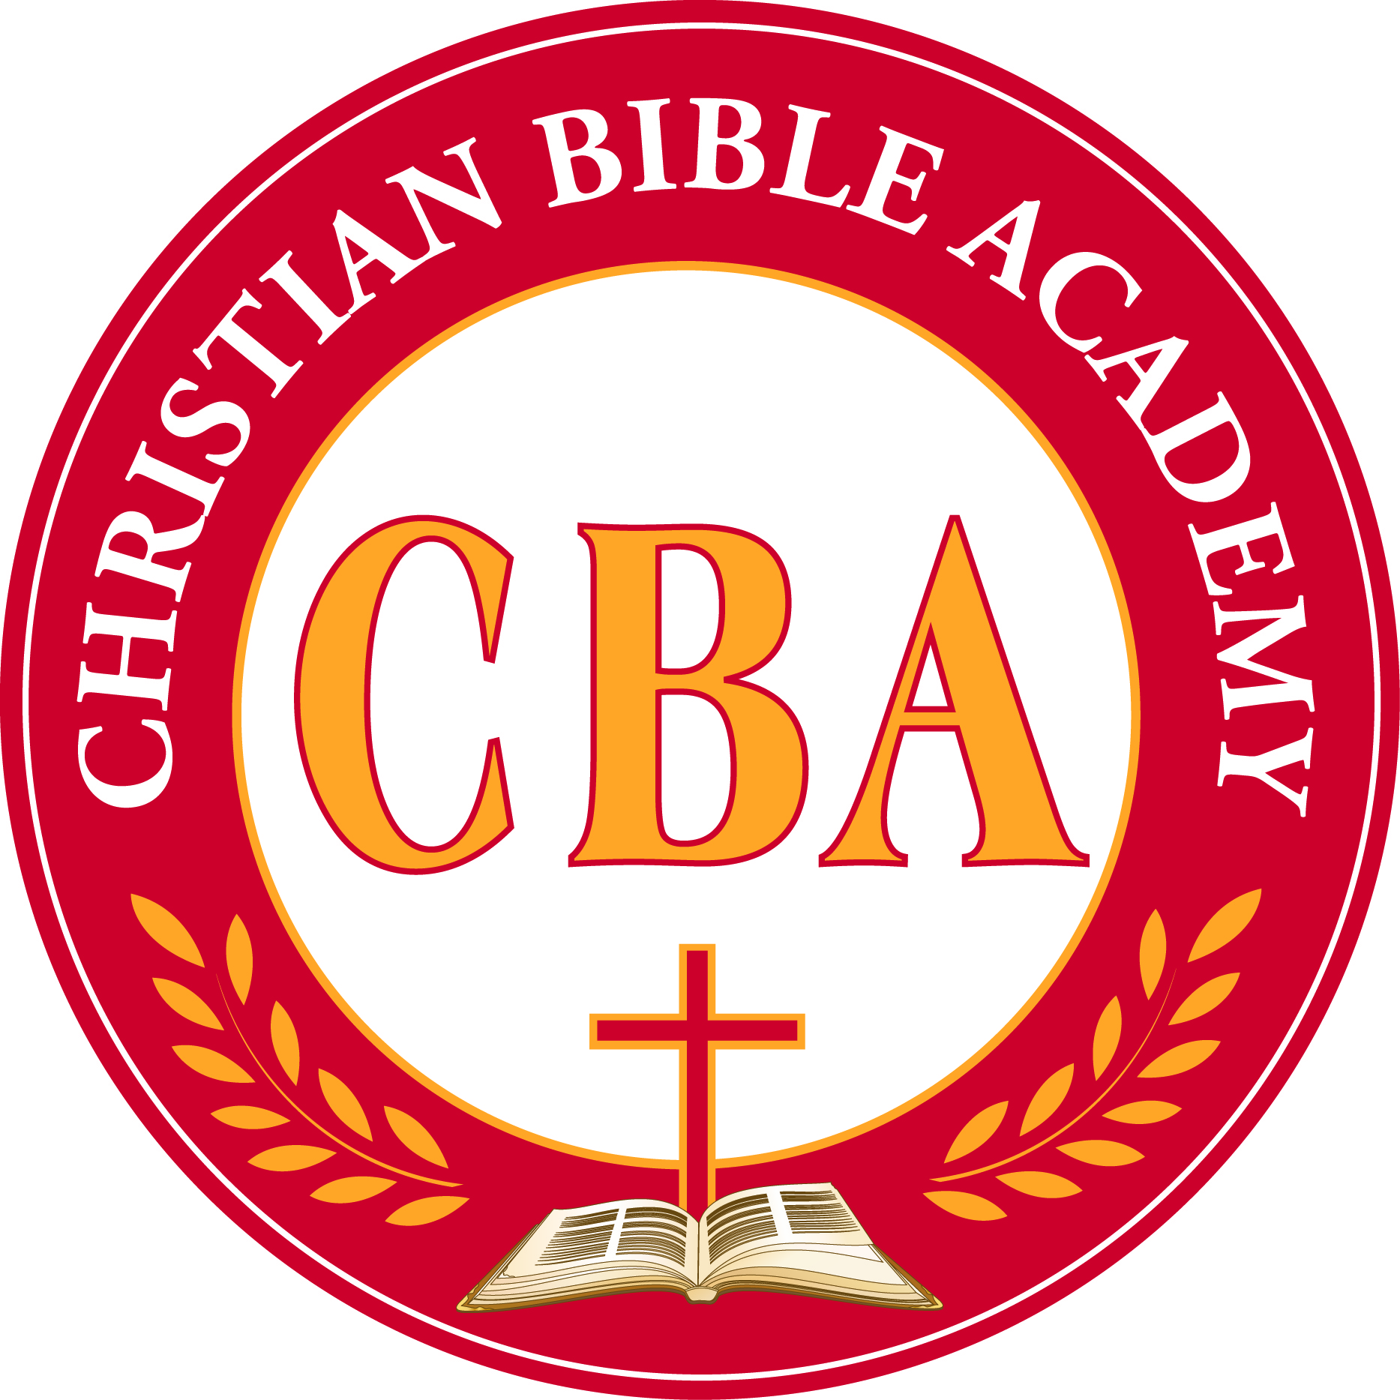
New Requirements Regarding Gang-Free Zones

For Child Care Centers

As a result Of House Bill 2086 that passed during the 81st Legislature, Regular Session, Chapter 42 of the Human Resource Code incudes section 42.064, and effective September 1, 2009. This new statute requires that information about gang-free zone be made available.

Parents Please Note The Following:
A Gang-Free is a designated area around a specific location where prohibited gang related activity is subject to increased penalty under Texas law. The specific locations include this day care center, Christian Bible Academy. The gang-free zone is within 1000 feet of our center. For more information about what constitutes a gang-free zone, please consult sections 71.028 and 71.029 of the Texas Penal Code.

To Know Where The Gang-Free Zone Ends?
The area that falls within a gang-free zone can vary depending on the type of location. The local municipal or county engineer may produce and update maps for the purposes of the prosecution. Parents may contact their local municipality or court house for information about obtaining a copy of a map if you so choose to do so.

What Is The Purpose Of Gang-Free Zones?
Similar to the motivation behind establishing Drug-Free zones, the purpose of Gang-Free zones is to deter certain types of criminal activity in areas where children gather by enforcing tougher penalties.

What Does This Mean For Christian Bible Academy?
We are informing parents or guardians of children attending the center about the new Gang-Free zone designation. This means you as parents or guardians need to be informed that certain gang related criminal activity or engaging in organized criminal activity within 1000 feet of our center is a violation of this law and therefore subject to increased penalty under state law.

When Do I Have To Comply With The New Requirements?
The law is already in effect, so we are sharing information regarding Gang-Free zones with you immediately. Licensing staff will offer technical assistance to facilitate compliance until rules are proposed and adopted, which is estimated to occur in March 2010. In the meantime, providers should update their operational policies and procedures to include providing the information mandated by this law to the parents or guardians of the children in care.
For further information please contact your licensing representative or your local licensing office.
Operational Policies

Immunization Requirements
Each child enrolled or admitted to child-care centers must meet applicable immunizations requirements specified by the Texas Department of Health Immunization Requirements in Texas Elementary and Secondary Schools and Institutions of Higher Education. This requirement applies to all children in care from birth through 17 years of age. Except as otherwise provided in this division, all immunizations required for the child’s age must be completed by the date of admission.

Tuberculin Testing Requirements
Texas Department of Health (TDH) requires tuberculosis testing for children in this child-care center. (I.e. documentation to indicate that each child in our care is free of active tuberculosis)*

**There is no state wide requirement for teachers or other school employees to have any vaccinations including Tuberculosis skin test. The center for Disease Control and Prevention discourages the use of any vaccinations including Tuberculosis skin test for persons who have no risk factors or exposure to any disease including TB. Therefore; Christian Bible Academy does not require any vaccinations including Tuberculosis skin testing for the staff.

Hearing and Vision Screening Requirements
The Special Senses and Communication Disorders Act, Texas Health and Safety Code, Chapter 36, requires a screening or a professional examination for possible vision and hearing problems for children enrolled in a child-care center who are – first-time enrollees who are four years of age or older and all children enrolled in programs who are four years of age by September 1 of each year will be screened for possible vision and hearing problems prior to completion of the first semester of enrollment or within 120 calendar days of enrollment, whichever is longest, or present evidence of screening conducted one year prior to enrollment in the first, third, fifth, or seventh-grade. Each child must complete a screening or examination within the school year. A licensed or certified screener or a health-care professional must conduct the screening.
Enrollment Procedures
Enrollment for Child Development Center is year round, depending on available space and following completion and submission of all required documents (enrollment form, birth certificate, current immunization records, registration agreement, milk, transportation, & medical authorization forms, Code of Conduct, and emergency card information.) Enrollment for CBA Preparatory School is August and January, depending on available space and following completion and submission of aforementioned required documents.
Health Checks
A health check is defined as a visual or physical assessment of a child to identify potential concerns about a child’s health, including signs or symptoms of illness and injury, in response to changes in the child’s behavior since the last date of attendance. These daily health checks will be conducted by our staff members in order to ensure that students are in a healthy condition when entering into our care. Signs that we look for may include:
- Breathing difficulties
- Severe coughing
- Discharge from the nose or eyes
- Changes in skin color
- Bruising or swelling
- Cuts, sores or rashes
- Fever
Staff members will communicate with parents on a daily basis to find out how their sleep, eating and drinking, toileting habits and/ or mood or behavior is / has been prior to drop off. Effective communications with parents are key elements of a health check. If a staff member finds any of the following symptoms, the staff member will make a recorded statement; notify the director and parents of such findings. In the event a staff member is suspicious of the neglect or abuse of a child, appropriate actions will be taken.
Parents will be notified of policy changes by letter of policy changes as soon as changes have been determined with a two week enforcement period.

